The Office of Small Business Affairs
Small Local Business Enterprise Program
Effective July 1, 2016

The Small Local Business Enterprise Program (hereinafter referred to as “SLBE”) is a race and gender-neutral procurement tool for Macon-Bibb County’s use in its efforts to ensure that all segments of its local business community have a reasonable and significant opportunity to participate in County contracts for construction, architectural and engineering services, professional services, non-professional services, and commodities. The Small Local Business Enterprise Program also furthers the County’s public interest to foster effective broad-based competition from all segments of the vendor community, including but not limited to, minority business enterprises, small business enterprises and local business enterprises.

Explanation of Affirmative Procurement Initiatives Presently Effective

- Price Preferences
  - This price preference applies to competitive bids. If a certified Small Local Business Enterprise submits a bid price that is the lowest among all certified SLBE firm bids and is also within 5% of the lowest bid from a non-certified Small Local Business Enterprise, the certified Small Local Business Enterprise is recommended to receive the contract award at the price that is originally bid. However, this price preference would not apply if the award to the certified Small Local Business Enterprise would result in a total contract cost that is, on an annual basis, more than $250,000 higher than the low bid; nor would it apply on a contract in which the total contract cost would exceed the County’s budgeted price for the contract.

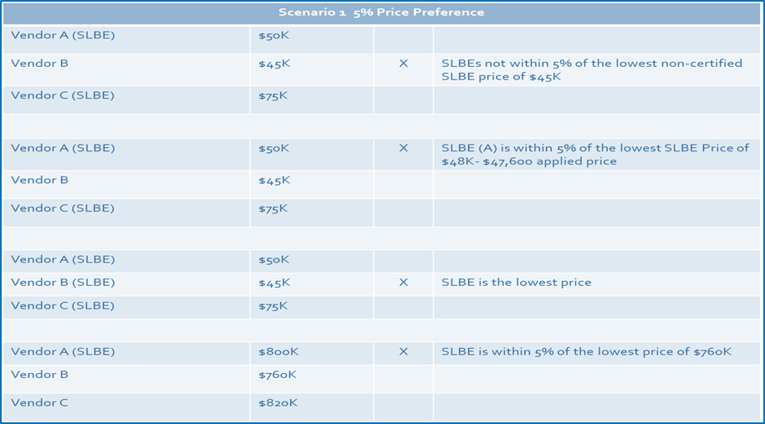
  - A firm that is not certified as a Small Local Business Enterprise may form a Joint Venture with a certified Small Local Business Enterprise for the purpose of receiving the 5% price preference. In order for the Joint Venture to qualify for application of the 5% price preference (or any other API under this SBLE Program), the certified Small Local Business Enterprise Joint Venture must perform at least 51% of the total contract cost, with its own forces, and the SLBE Joint Venture partner must own and manage at least 51% of the Joint Venture as confirmed in a written agreement submitted with the actual bid. If the Joint Venture bid price is within 5% of the overall lowest bid price, the Joint Venture is recommended to Commission to receive contract award. However, this price preference would not apply if the award to the Joint Venture entity would result in a total contract cost that is, on an annual basis, more than $250,000 higher than the low bid; nor would it apply on a contract in which the total contract cost would exceed the County’s budgeted price for the contract.

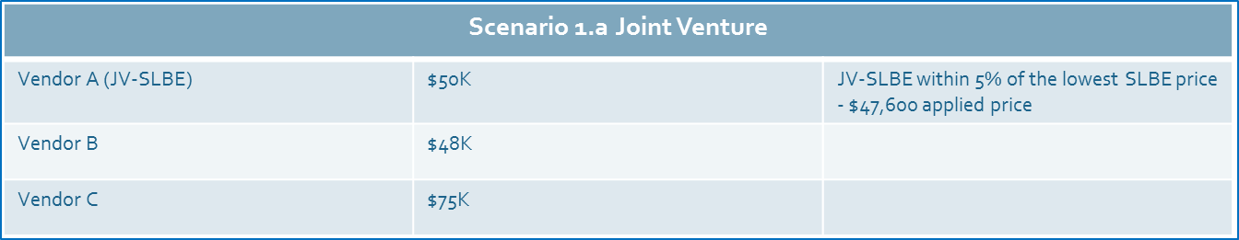

Explanation of Affirmative Procurement Initiatives

- Price Preferences
  - This price preference applies to competitive bids. If a certified Small Local Business Enterprise submits a bid price that is the lowest among all certified SLBE firm bids and is also within 5% of the lowest bid from a non-certified Small Local Business Enterprise, the certified Small Local Business Enterprise is recommended to receive the contract award at the price that is originally bid. However, this price preference would not apply if the award to the certified Small Local Business Enterprise would result in a total contract cost that is, on an annual basis, more than $250,000 higher than the low bid; nor would it apply on a contract in which the total contract cost would exceed the County’s budgeted price for the contract.

  - A firm that is not certified as a Small Local Business Enterprise may form a Joint Venture with a certified Small Local Business Enterprise for the purpose of receiving the 5% price preference. In order for the Joint Venture to qualify for application of the 5% price preference (or any other API under this SBLE Program), the certified Small Local Business Enterprise Joint Venture must perform at least 51% of the total contract cost, with its own forces, and the SLBE Joint Venture partner must own and manage at least 51% of the Joint Venture as confirmed in a written agreement submitted with the actual bid. If the Joint Venture bid price is within 5% of the overall lowest bid price, the Joint Venture is recommended to Commission to receive contract award. However, this price preference would not apply if the award to the Joint Venture entity would result in a total contract cost that is, on an annual basis, more than $250,000 higher than the low bid; nor would it apply on a contract in which the total contract cost would exceed the County’s budgeted price for the contract.

Proposed Application of 5% Local Price Preference $250,000 Cap Scenario 1
Hard Bid Procurement Solicitation

Vendor A (Certified SLBE) $500,000 5% Applied $476,250
Vendor B $475,000 Low Bid $475,000 X
Vendor C (Non-Certified SLBE) $550,000 High Bid $550,000

Explanation- Vendor B awarded contract because the applied 5% local price preference to Vendor A (Certified SLBE) is greater than the low bid price of Vendor B. The differential is greater than $23,750, (5% of low bid).

Vendor A (Certified SLBE) $1,045,000 5% Applied $995,000 X
Vendor B $1,000,000 Low Bid $1,000,000
Vendor C (Non-Certified SLBE) $1,200,000 High Bid $1,200,000

Explanation- Vendor A awarded contract because applied 5% local price preference to Vendor A (Certified SLBE) is less than the low bid price. The differential is within $50,000, (5% of low bid).

Vendor A (Certified SLBE) $2,364,676 5% Applied $2,252,006 X
Vendor B $2,253,390 Low Bid $2,253,390
Vendor C (Non-Certified SLBE) $2,580,376 High Bid $2,580,376

Explanation- Vendor A awarded contract because applied 5% local price preference to Vendor A (Certified SLBE) is less than the low bid price. The differential is within $112,669.50, (5% of low bid).
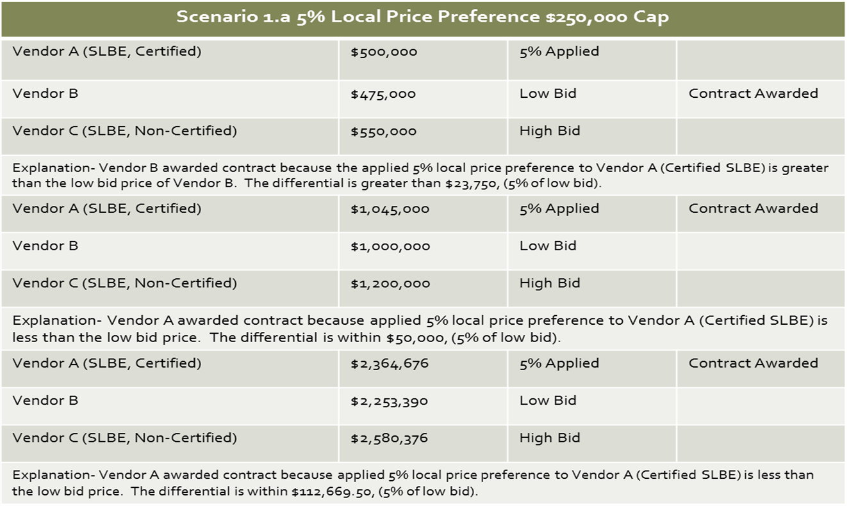

Proposed Application of 5% Local Price Preference $250,000 Cap Scenario 1.a Joint Ventures
Vendor A (Certified SLBE-JV) $3,800,000 5% Applied $3,618,500 X
Vendor B $4,000,000 High Bid $4,000,000
Vendor C (SLBE) $3,630,000 Low Bid $3,630,000

Explanation- Vendor A awarded contract because applied 5% local price preference to Vendor A (Certified SLBE-JV) is less than the low bid price. The differential is within $181,500, (5% of low bid).

Vendor A (Certified SLBE-JV) $5,000,000 5% Applied $4,756,250 X
Vendor B $6,000,000 High Bid $6,000,000
Vendor C (SLBE) $4,875,000 Low Bid $4,875,000

Explanation- Vendor A awarded contract because applied 5% local price preference to Vendor A (Certified SLBE-JV) is less than the low bid price. The differential is within $243,750, (5% of low bid).

